**Spring 2017**

**ESI 5359**

**Industrial Financial Decisions**

**Yezehao Huai (5965823)**

**Chapter 7 Homework**

**2. Svoboda Corporation comparative balance sheets at December 31 (in millions)**

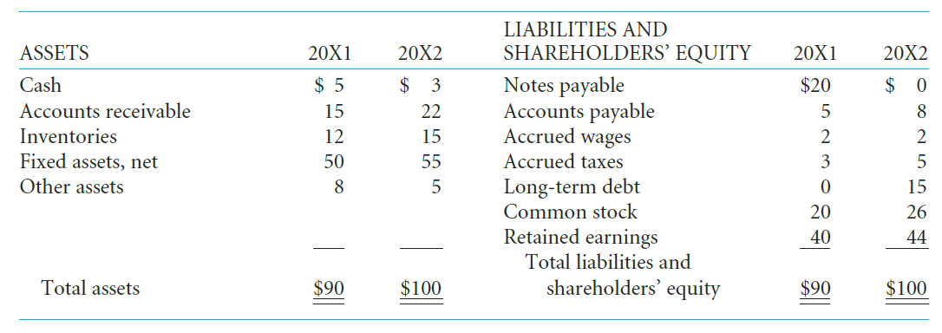

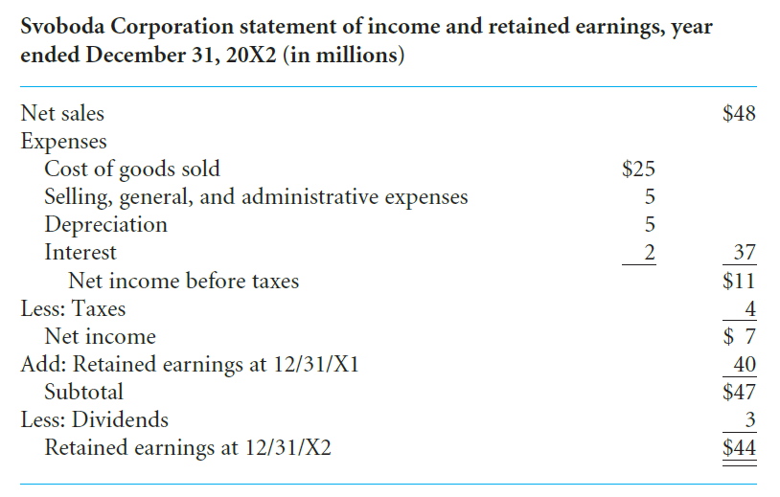

1. **Prepare a flow of funds (sources and uses of funds) statement for 20X2 for the Svoboda Corporation.**

Svoboda Corporation statement of flow of funds

For the year ended December 31,20X2 (in millions)

|  |  |  |  |
| --- | --- | --- | --- |
| SOURCES |  | USES |  |
| Funds provided by operations  Net profit  Depreciation |  | Dividends  Additions to fixed assets |  |
| $7 | $3 |
| 5 | 10 |
| Decrease, Other assets | 3 | Increase, accounts receivable | 7 |
| Increase, accounts payable | 3 | Increase, inventories | 3 |
| Increase, accrued taxes | 2 | Decrease, notes payable | 20 |
| Increase, long-term debt | 15 |  |  |
| Increase, common stock | 6 |  |  |
| **Decrease, cash** | 2 |  |  |
|  | $43 |  | $43 |

1. **b. Prepare a statement of cash flows for 20X2 using the indirect method for the Svoboda Corporation.**

Svoboda Corporation statement of Cash flows statement

For the year ended December 31,20X2 (in millions)

|  |  |
| --- | --- |
| CASH FLOW FROM OPERATING ACTIVITIES |  |
| Net income | $7 |
| Depreciation | 5 |
| Cash provided (used) by current assets and  Operating-related liabilities |  |
|  |
| Increase, account payable | 3 |
| Increase, accrued taxes | 2 |
| Increase, accounts receivable | (7) |
| Increase, inventories | (3) |
| Net cash provided(used) by operating activities | $7 |
|  |  |
| CASH FLOW FROM INVESTING ACTIVITIES |  |
| Addition to fixed assets | $(10) |
| Other assets | 3 |
| Net cash provided(used) by investing activities | $(7) |
|  |  |
| CASH FLOW FROM FINANCING ACTIVITIES |  |
| Decrease in short-term borrowings | $(20) |
| Additions to long-term borrowing | 15 |
| Common stock | 6 |
| Dividends paid | (3) |
| Net cash provided(used) by financing activities | $(2) |
| Increase(decrease) in cash | $(2) |
| Cash, December 31,20X1 | 5 |
| Cash, December 31,20X2 | $3 |
|  |  |
| **Supplemental cash-flow disclosures** |  |
| Interest paid | $2 |
| Taxes paid | 2 |

**4. Prepare a cash budget for the Ace Manufacturing Company, indicating receipts and disbursements for May, June, and July. The firm wishes to maintain at all times a minimum cash balance of $20,000. Determine whether or not borrowing will be necessary during the period, and if it is, when and for how much. As of April 30, the firm had a balance of $20,000 in cash.**

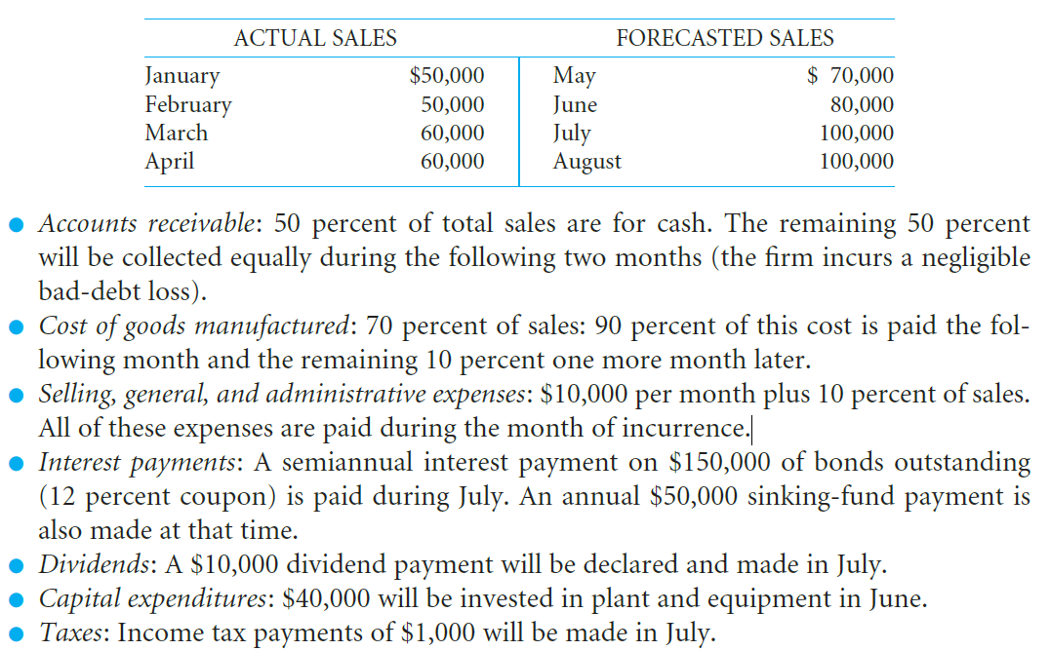

1. Schedules of projected sales and collections for May to July (in thousands)

|  |  |  |  |  |  |  |
| --- | --- | --- | --- | --- | --- | --- |
|  | MAR. | APR. | MAY | JUNE | JULY | AUG. |
| Fram A: sales  Credit sales,50%  Cash sales,50%  Total sales,100% | $30.0  30.0  $60.0 | $30.0  30.0  $60.0 | $35.0  35.0  $70.0 | $40.0  40.0  $80.0 | $50.0  50.0  $100.0 | $50.0  50.0  $100.0 |
|  | | | | | | |
| Frame B:Cash Collections |  |  |  |  |  |  |
| Cash sales, this month |  |  | $35.0 | $40.0 | $50.0 |  |
| 50% of last month’s credit sales |  |  | 15.0 | 17.5 | 20.0 |  |
| 50% of 2month-old credits ales |  |  | 15.0 | 15.0 | 17.5 |  |
| Total sales receipts |  |  | $65.0 | $72.5 | $87.5 |  |

1. Schedule of projected disbursements for purchases and operating expenses for May to July (in thousands)

|  |  |  |  |  |  |  |
| --- | --- | --- | --- | --- | --- | --- |
|  | MAR. | APR. | MAY | JUNE | JULY | AUG. |
| Frame A:Cost of goods manufactured  Current month sales,70%  Frame B:Cash Disbursements  For Cost of goods manufactured  Last month cost,90%  2-month old cost,50%  Total disbursements for cost of goods manufactured,100% | $42.0 | $42.0 | $49.0    $37.8  4.2  $42.0 | $56.0    $44.1  4.2  $48.3 | $50.0    $50.4  4.9  $55.3 | $50.0 |
|  | | | | | | |
| Frame C:Cash Disbursements  For selling, general, and  Administrative expenses |  |  |  |  |  |  |
| Current month expenses,100% |  |  | $17.0 | $18.0 | $20.0 |  |
| Total disbursements for  expenses |  |  | $59.0 | $66.3 | $75.3 |  |
|  |  |  |  |  |  |  |

1. Schedule of projected total cash disbursements for May to July (in thousands)

|  |  |  |  |
| --- | --- | --- | --- |
|  | MAY | JUNE | JULY |
| Total disbursements for purchases and operating expenses | $59.0 | $66.3 | $75.3 |
| Capital expenditures |  | 40.0 |  |
| Dividend payments |  |  | 10.0 |
| Interest payment |  |  | 59.0 |
| Taxes |  |  | 1.0 |
| Total cash disbursements | $59.0 | $106.3 | $145.3 |

1. Schedule of projected net cash flows and cash balances for May to July (in thousands)

|  |  |  |  |
| --- | --- | --- | --- |
|  | MAY | JUNE | JULY |
| Beginning cash balance, without additional financing  Total cash receipts  Total cash disbursements  Net cash flow  Ending cash balance, without additional financing | $20.0  65.0  59.0  6.0  $26.0 | $26.0  72.5  106.3  (33.8)  $(7.8) | $(7.8)  87.5  145.3  (57.8)  $(65.6) |
|  |  |  |  |

The company don’t need to borrow money to maintain minimum cash balance on May, but need to borrow $27,800 on June and $85,600 on July.